**ARRAYS**

**LAB # 5**



**Spring 2022**

**CSE102L Computer Programming Lab**

Submitted by: **Ali Asghar**

Registration No. : **21PWCSE2059**

Class Section: **C**

“On my honor, as student of University of Engineering and Technology, I have neither given nor received unauthorized assistance on this academic work.”

Student Signature: ______________

Submitted to:

**Engr. Abdullah Hamid**

July 4, 2022

Department of Computer Systems Engineering

University of Engineering and Technology, Peshawar

**Lab Objective(s)**

* To understand the programming knowledge using Array
* To understand the programming using array

**TASK # 1:**

**Title:**

Write a program in which you take your registration number and n…….Use loops for input and output.

**CODE SCREENSHOTS:**

Here is the screenshot of the code.

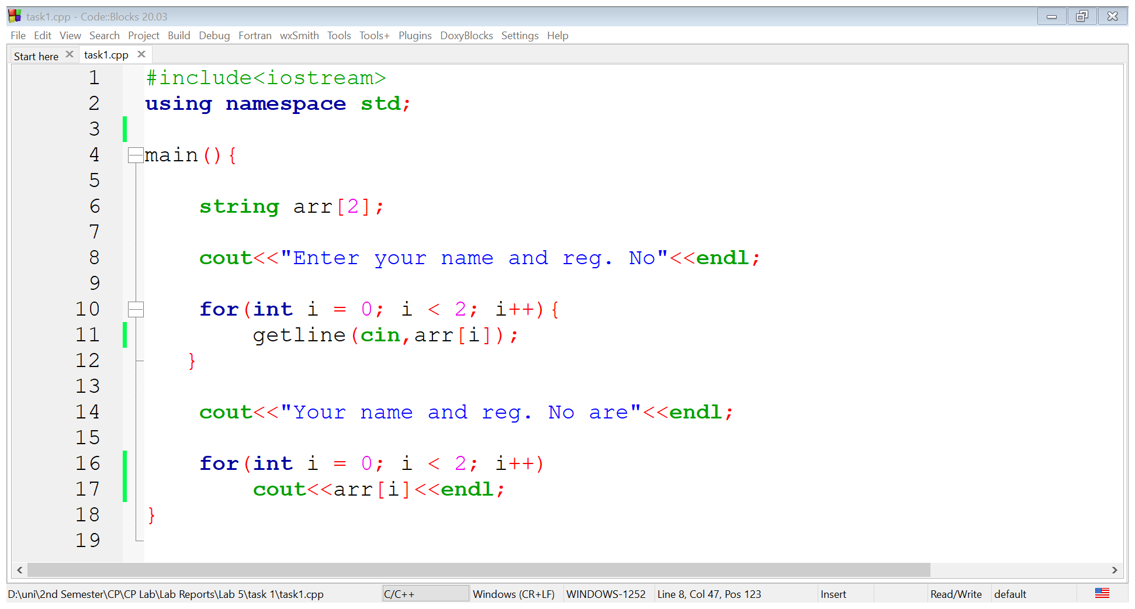

### **OUTPUT (COMPILATION, DEBUGGING & TESTING):**

Here is the screenshot of the output of above code.

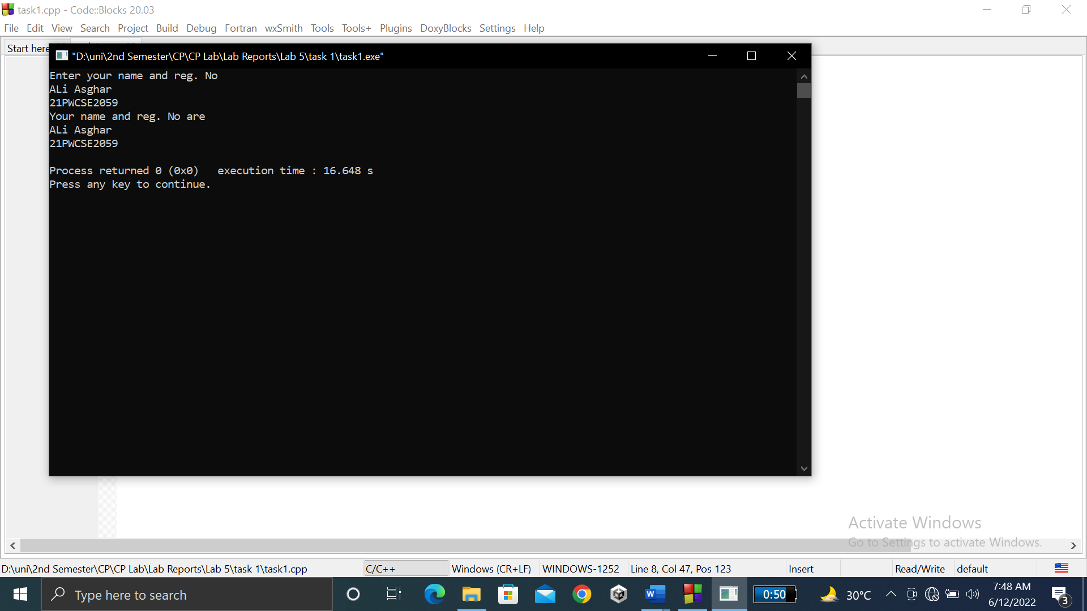

**TASK # 2:**

**Title:**

Write a program……………console (3 values in a row) (use separate loops for input and output operation).

**CODE SCREENSHOTS:**

Here is the screenshot of the code.

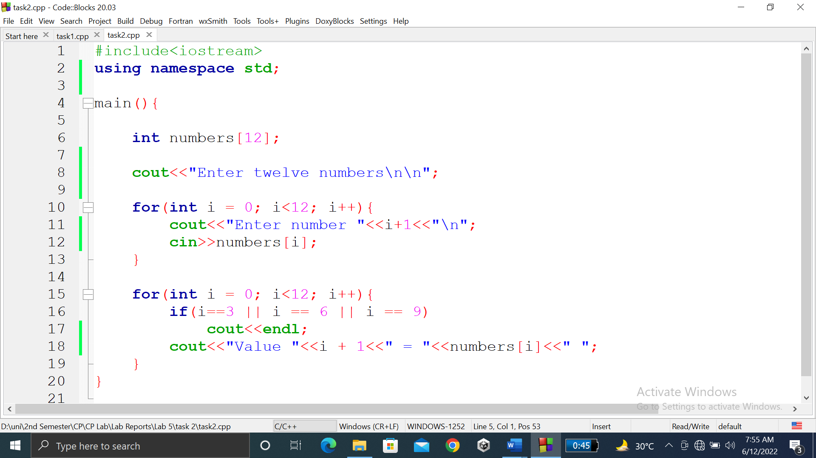

### **OUTPUT (COMPILATION, DEBUGGING & TESTING):**

Here is the screenshot of the output of above code.

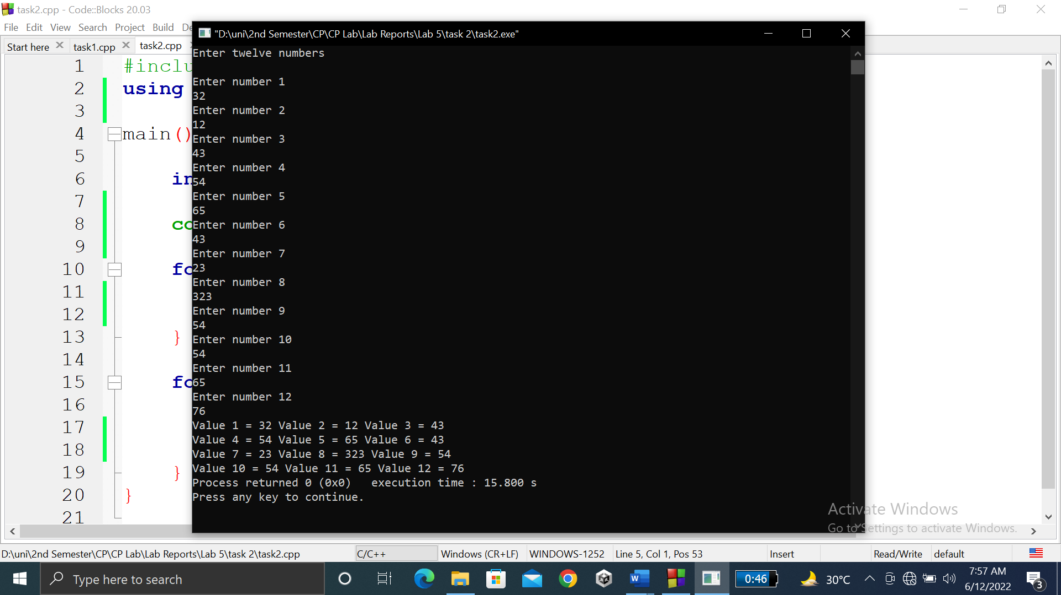

**TASK # 3:**

**Title:**

Write a program…………….of numbers (use separate loops for input operation and calculation).

**CODE SCREENSHOTS:**

Here is the screenshot of the code.

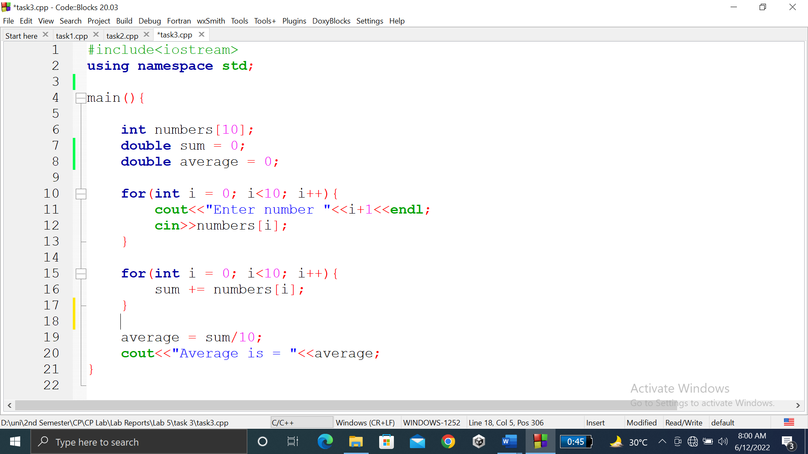

### **OUTPUT (COMPILATION, DEBUGGING & TESTING):**

Here is the screenshot of the output of above code.

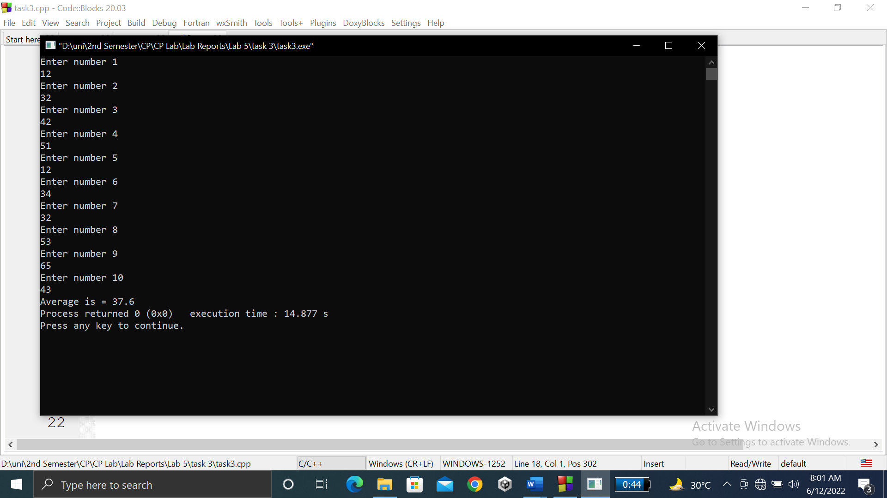

**TASK # 4:**

**Title:**

Write a program to input multiple values from…(use separate loops for input operation and calculation).

**CODE SCREENSHOTS:**

Here is the screenshot of the code.

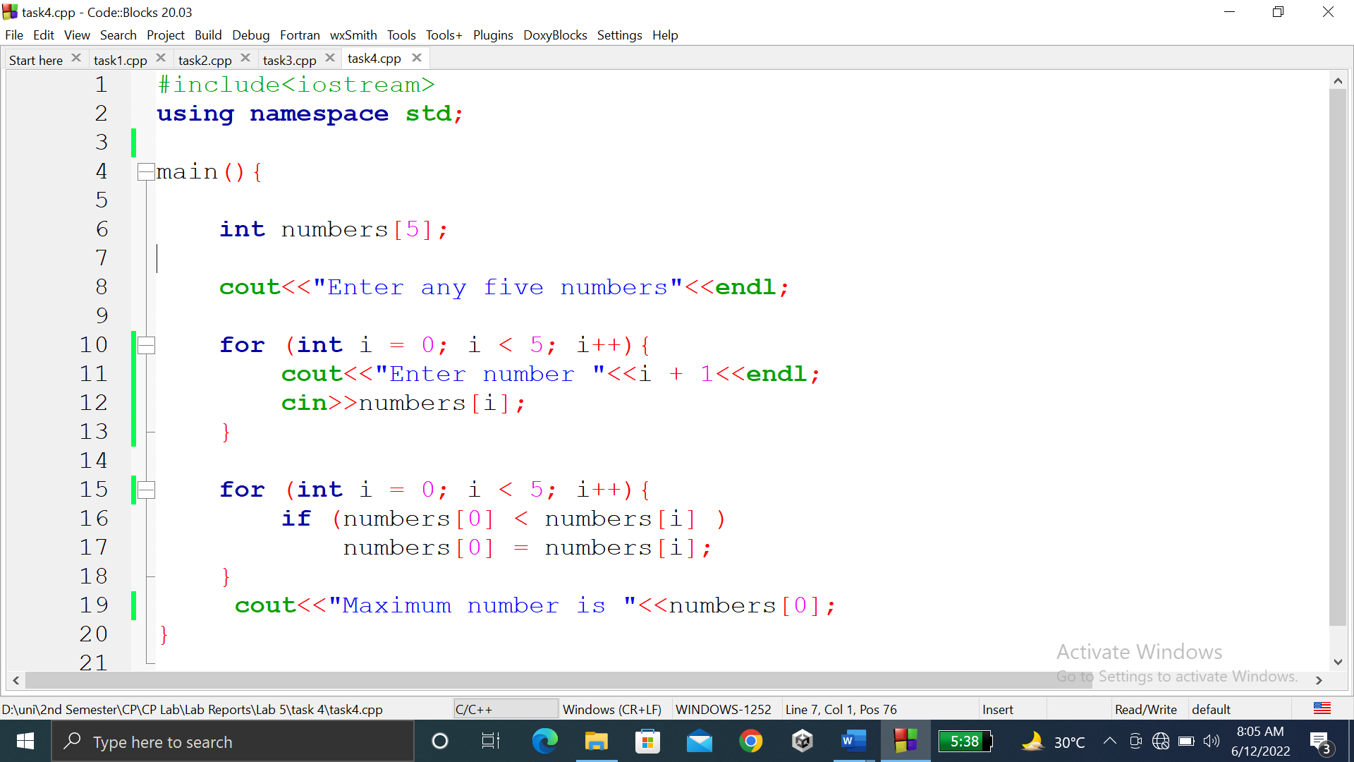

### **OUTPUT (COMPILATION, DEBUGGING & TESTING):**

Here is the screenshot of the output of above code.

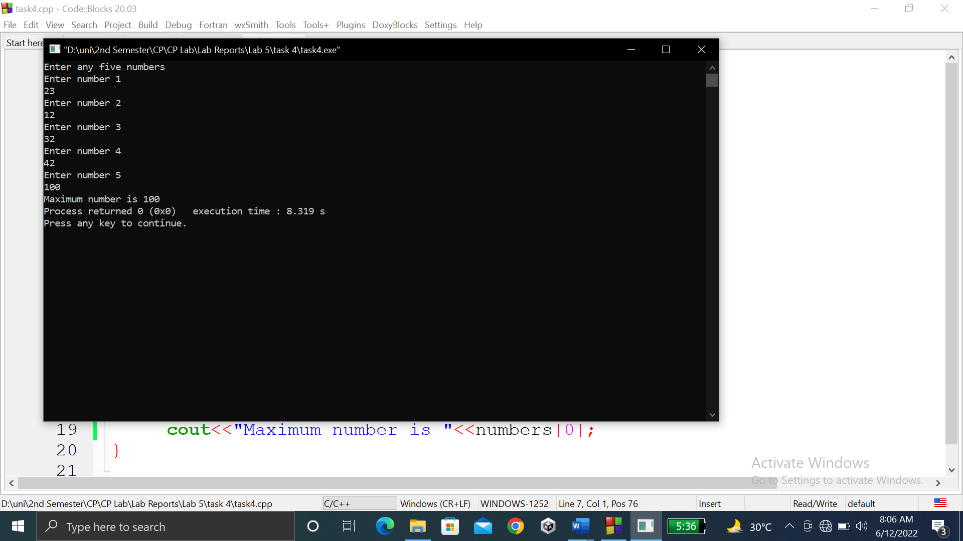

**TASK # 5:**

**Title:**

Write a program to input two arrays from user and find the sum of arrays (element by element).

**CODE SCREENSHOTS:**

Here is the screenshot of the code.

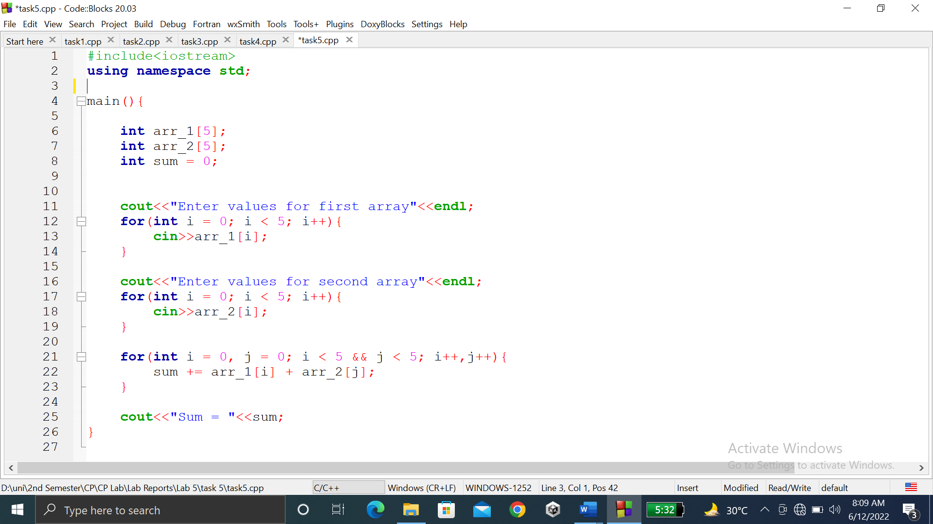

### **OUTPUT (COMPILATION, DEBUGGING & TESTING):**

Here is the screenshot of the output of above code.

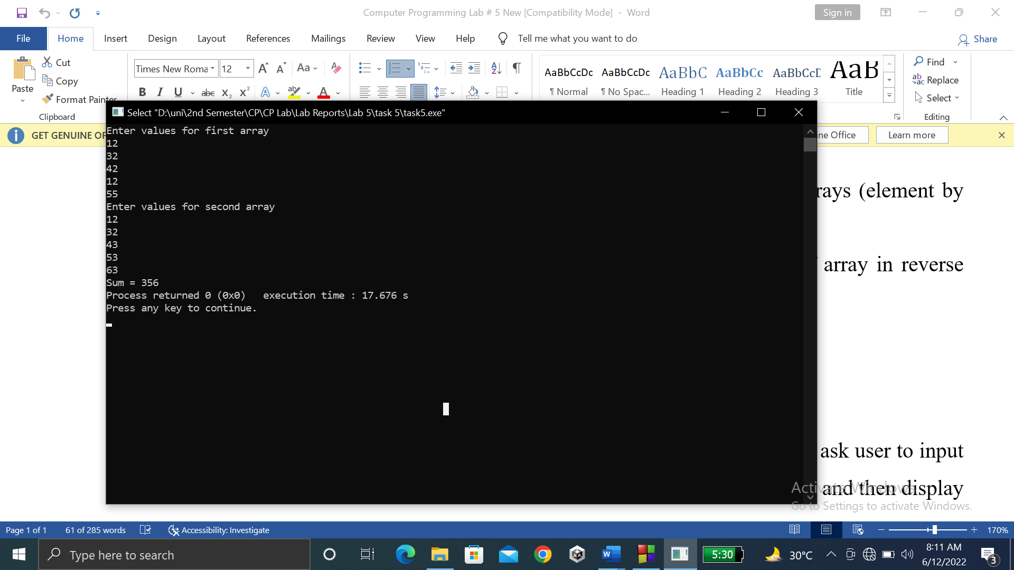

**TASK # 6:**

**Title:**

Write a program ………..of array in reverse order (use separate loops for input and output operation).

**CODE SCREENSHOTS:**

Here is the screenshot of the code.

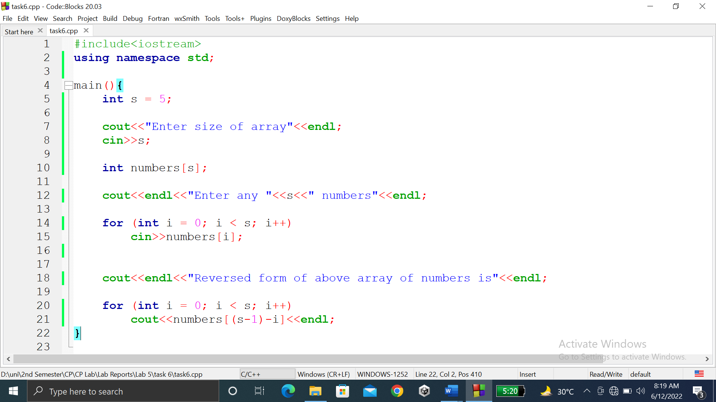

### **OUTPUT (COMPILATION, DEBUGGING & TESTING):**

Here is the screenshot of the output of above code.

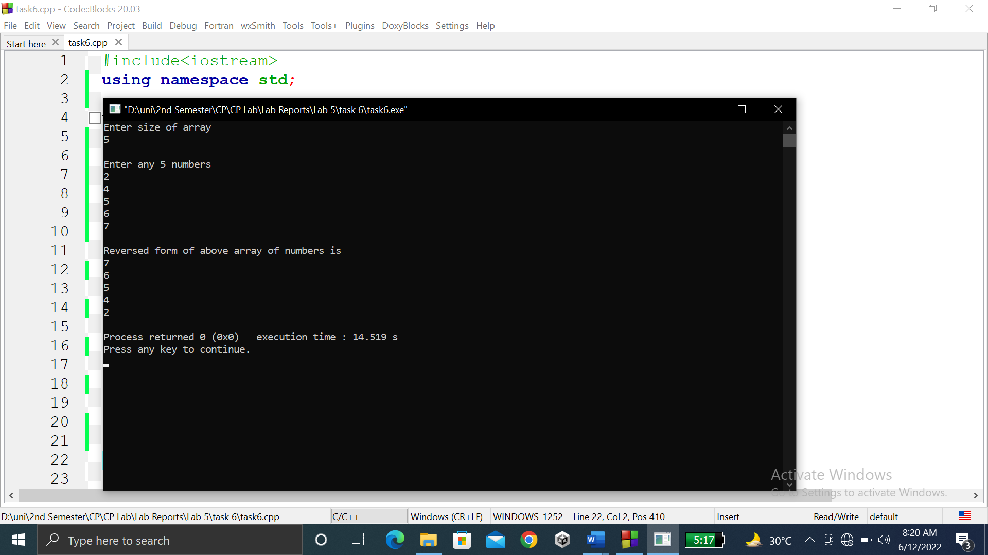

**TASK # 7:**

**Title:**

Write a program to input multiple………………..(use different loops for input operation and calculation).

**CODE SCREENSHOTS:**

Here is the screenshot of the code.

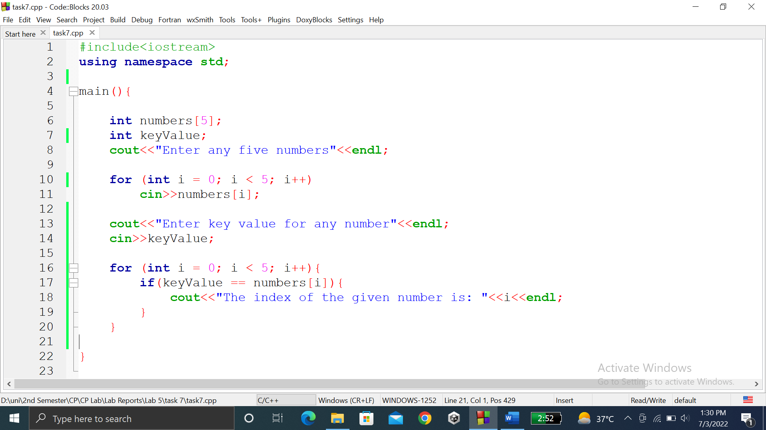

### **OUTPUT (COMPILATION, DEBUGGING & TESTING):**

Here is the screenshot of the output of above code.

